Name : Vishnu Ram
Email: vishnuram1896@gmail.com
Github:

Assignment: Automated S3 Bucket Cleanup Using AWS Lambda and Boto3

Objective
The objective of this assignment is to gain hands-on experience with AWS Lambda and Boto3 by creating an automated solution that deletes files older than 30 days from an Amazon S3 bucket.

Architecture Overview
S3 Bucket → AWS Lambda Function → Boto3 SDK → Delete Old Files (>30 Days)
The Lambda function scans all objects in the S3 bucket, identifies files older than 30 days, and automatically deletes them.

Step 1: Create an S3 Bucket

Procedure
- Logged in to the AWS Management Console.
- Opened the Amazon S3 service.
- Clicked on Create Bucket/CLI.
- Entered a unique bucket name.
- Kept default settings.
- Created the bucket successfully.

Outcome
A new S3 bucket was created for storing files to be monitored and cleaned up automatically.

Screenshot: S3 Bucket Creation.
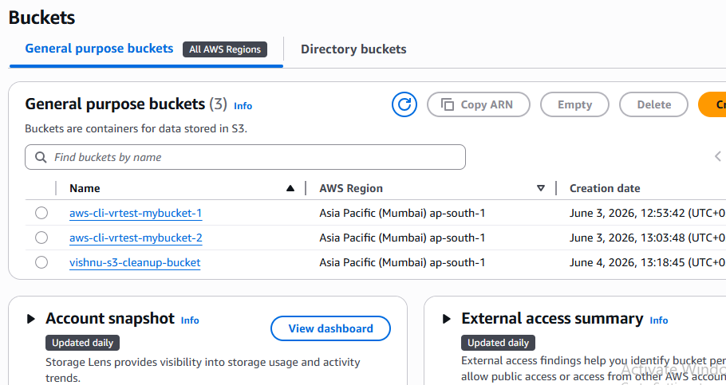

Step 2: Upload Files to the S3 Bucket

Procedure
- Opened the created S3 bucket.
- Uploaded multiple files into the bucket.
- Verified that all files were successfully uploaded.

Outcome
Files were available in the bucket for cleanup testing.

Screenshot: Uploaded Files in S3 Bucket.
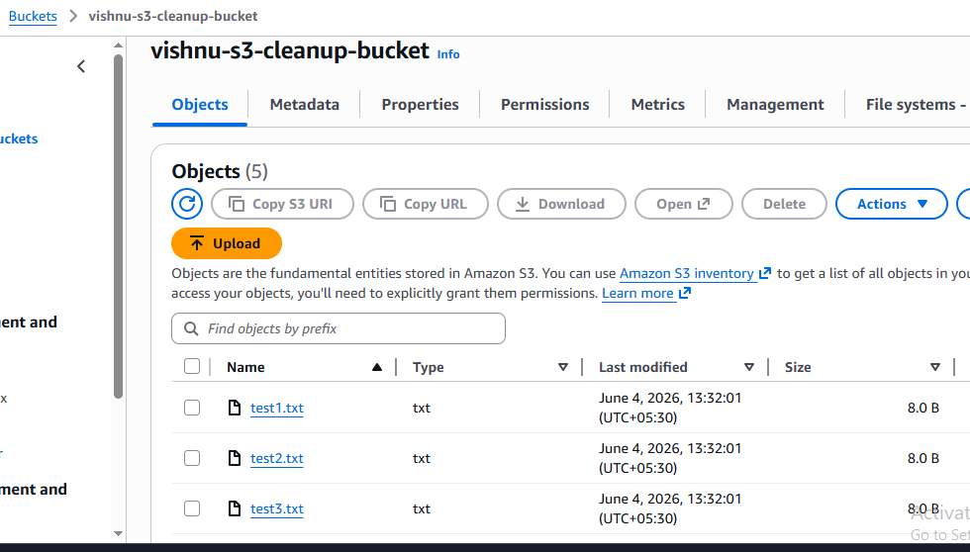

Step 3: Create IAM Role for Lambda

Procedure
- Opened the IAM Dashboard.
- Selected Roles.
- Clicked Create Role.
- Selected AWS Service as trusted entity.
- Selected Lambda as the use case.
- Attached the following policy:
- AmazonS3FullAccess
- Created the role successfully.

Outcome
An IAM role was created with permissions required to access and delete S3 objects.

Screenshot: IAM Role Creation.
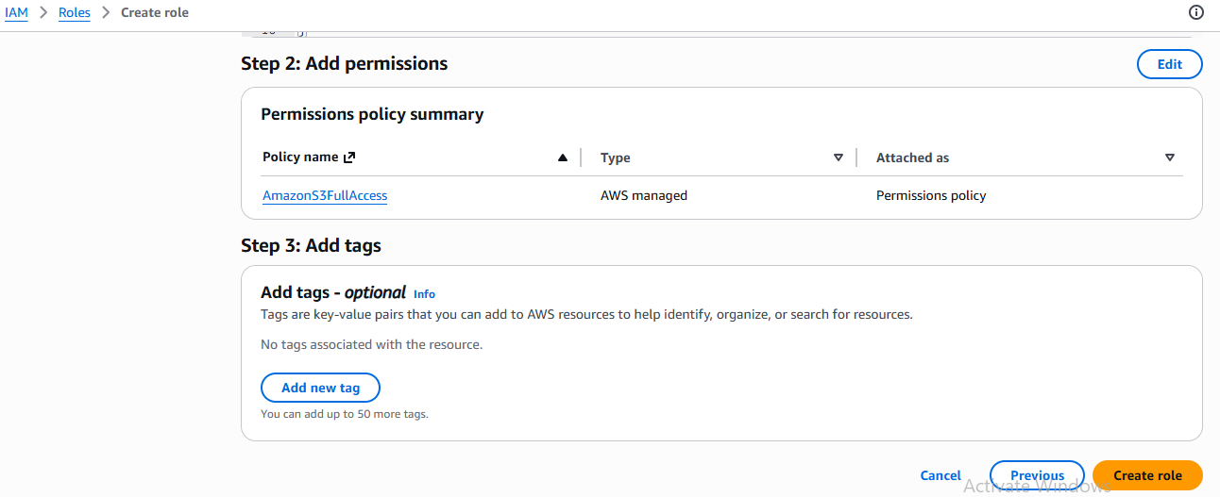

Screenshot: Attached AmazonS3FullAccess Policy.
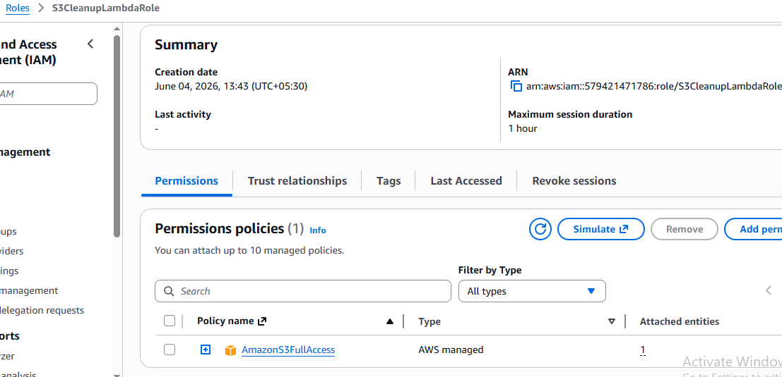

Step 4: Create Lambda Function

Procedure
- Opened AWS Lambda Console.
- Clicked Create Function.
- Selected Author From Scratch.
- Entered Function Name.
- Selected Python Runtime.
- Assigned the IAM Role created previously.
- Created the Lambda Function.

Outcome
Lambda function was successfully created and configured.

Screenshot: Lambda Function Configuration.
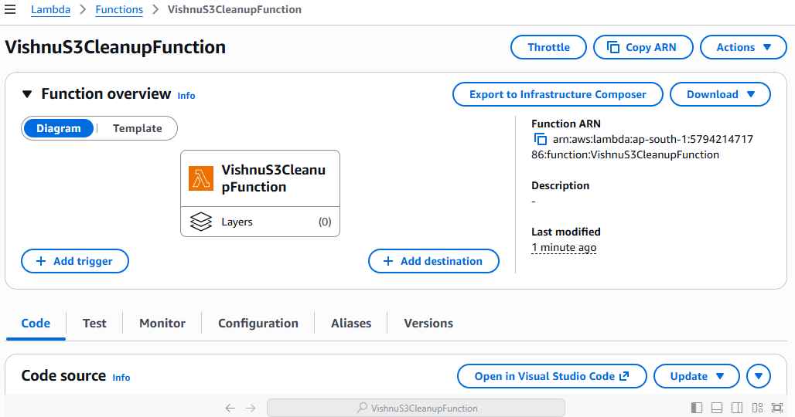

Step 5: Implement Lambda Code

Lambda Function Code
import boto3
from datetime import datetime, timezone, timedelta
s3 = boto3.client('s3')
BUCKET_NAME = 'your-bucket-name'
def lambda_handler(event, context):
response = s3.list_objects_v2(
Bucket=BUCKET_NAME
)
if 'Contents' not in response:
print("Bucket is empty")
return
current_time = datetime.now(timezone.utc)
for obj in response['Contents']:
file_age = current_time - obj['LastModified']
if file_age > timedelta(days=30):
s3.delete_object(
Bucket=BUCKET_NAME,
Key=obj['Key']
)
print(f"Deleted: {obj['Key']}")
return {
'statusCode': 200
}

Outcome
The Lambda function was configured to:
- Connect to S3 using Boto3.
- Retrieve all files from the bucket.
- Calculate file age.
- Delete files older than 30 days.
- Log deleted file names.

Screenshot: Lambda Code.
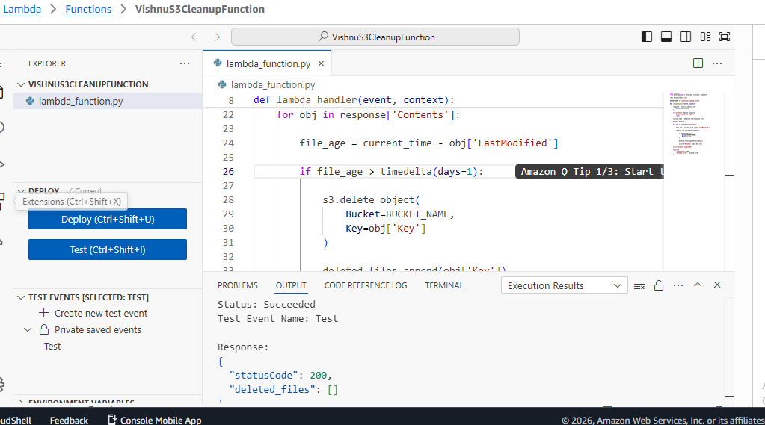

Step 6: Deploy and Test Lambda Function

Procedure
- Clicked Deploy.
- Created a Test Event.
- Executed the Lambda Function.
- Reviewed execution results.

Outcome
Lambda executed successfully and identified files eligible for deletion.

Screenshot: Lambda Test Execution.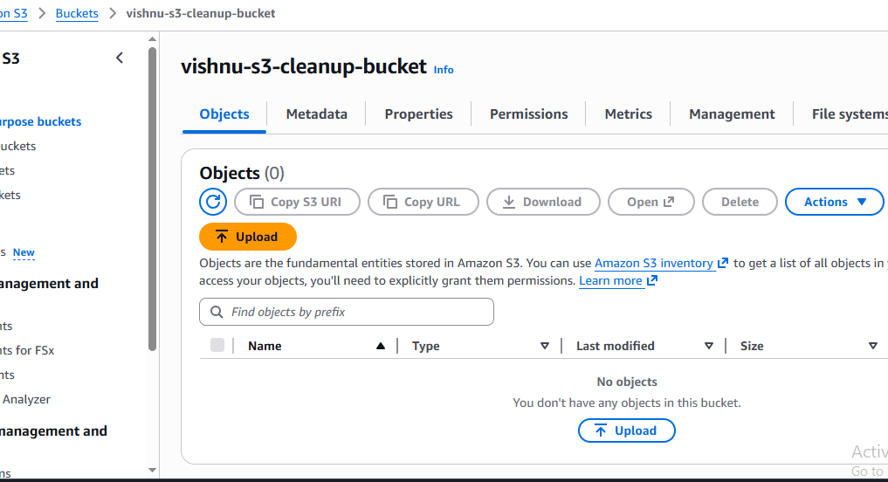

Step 7: Verify Cleanup in S3 Bucket

Procedure
- Opened the S3 bucket.
- Refreshed bucket contents.
- Verified that old files were removed.
- Verified that recent files remained available.

Outcome
Only files newer than 3 minutes remained in the bucket.

Screenshot: S3 Bucket After Cleanup.


Outcome
Execution logs confirmed successful deletion of old files.

Results
The AWS Lambda function successfully automated S3 bucket cleanup by deleting files older than 3 minutes. The solution reduced manual effort and demonstrated the integration of AWS Lambda, IAM, S3, CloudWatch, and Boto3.

AWS Services Used
- Amazon S3
- AWS Lambda
- AWS IAM
- Amazon CloudWatch
- Boto3 SDK

Conclusion
This assignment successfully demonstrated how AWS Lambda and Boto3 can be used to automate S3 bucket maintenance. The Lambda function scanned bucket contents, identified files older than 3 minutes, and deleted them automatically, ensuring efficient storage management and reducing operational overhead.

